NATIONAL CONCILIATION SERVICE (NCS)
ALTERNATIVE DISPUTE RESOLUTION (ADR) via CONCILIATION/MEDIATION
Would you like to try to settle your case without going to Court?

The NCS provides a free and confidential Conciliation (mediation) service for consumers who have been unable to settle a dispute with a trader (business), and may now be considering taking the matter to the civil courts
If you have been unable to settle the matter directly with the trader, and are considering pursuing the matter via the civil courts or binding Arbitration for a judicial decision over the matter, then this service could give you the opportunity to resolve your dispute with the trader at no cost to either and without having to attend a court hearing, or applying for the NCS Arbitration process.
Should you agree to the NCS process of Conciliation, you will need to complete an NCS Case Reference Form giving full details of your complaint for it to be assessed by the NCS administration department to see if the trader is a subscriber to this service, and to see if it is suitable for this process

Once assessed by admin, a copy of your complaint will be forwarded to the trader for their formal response, and once the traders reply to your complaint is received, the case will be referred to an Independent Conciliator (Case-Handler) who will reassess the case, then not as a judge or arbitrator but as a neutral third party, will attempt to arrange a mutually agreed settlement to the dispute. If that is not possible, the Conciliator may give a non-binding opinion or recommendation to settle the dispute

It is important to consider that Conciliation, much like Mediation, generally requires both parties to step forward from their previous stance over the matter, or at the very least and with the assistance of the Independent Conciliator, reconsider the matter, which has led to this present state of deadlock The view/s and/or opinion/s of the Conciliator whilst non-binding and confidential, are intended to assist both parties either reach a settlement over the matter, or decide on a more judicial form of dispute resolution such as litigation via the civil courts or legally binding Arbitration for cases that have been unsuccessful in reaching a settlement via this process of independent conciliation/mediation

Please consider the following | statements: | Yes | No
For Conciliation to be successful there needs to be some flexibility from all parties and a willingness to listen and consider each other's positions. Can you a agree to this?
Can you confirm that you have enough information about the claim, to allow you to enter into the NCS process of ADR?
Conciliation is a voluntary option and is only available if you can answer YES to the above statements. If you have answered NO to any of the statements, Conciliation is not suitable for your case.
There should be no negative impact to your case if you decide that this process of Conciliation is unsuitable for your dispute, although a judge or arbitrator may ask for the reason/s why you decided not to attempt conciliation/mediation via this process of Chartered Trading Standards Institute Certified (CTSI) Alternative Dispute Resolution (ADR), before pursing the matter via the courts

What are the benefits of NCS process of Conciliation?
- Conciliation is a free and quicker process than attending a court hearing.
- Conciliation is undertaken by way of documentation and written statements only. You will not be required to attend a hearing or speak directly with the trader. You will not be required to communicate directly with the trader as all communications must be directed via an Independent Conciliator, who to ensure impartiality, will share all relevant communications with both parties. You will not be required to speak to the trader although occasionally the Conciliator may contact either party by telephone
- The process is obviously less formal than a court hearing, and the parties are in control of the outcome, rather than having a decision imposed upon them
- All discussions are confidential and without prejudice.
- If you agree to settle your dispute via this process of Conciliation, the Conciliator will ask both parties to confirm the agreement or settlement and the process of Conciliation will end. Should either party subsequently fail to abide by the agreement, you or the other party could apply to the court to request it to be enforced.
If you wish to apply for Conciliation , it is essential that you complete the NCS Case Reference Form (CRF) (LINK) giving your full contact details including a direct telephone number & email address as if possible, all communications will be via electronic communications (emails etc) Please supply copies only of all information in support of your claim, for example, invoices, estimates expert reports etc., anything you have that may support your complaint

What happens next?
Once the NCS administration department has received the completed CRF and checked to see if the trader is a subscriber to our services, your case will be sent to an Independent Conciliator who will access your case to see if it is suitable and then contact the parties directly

The conciliator will send both parties a letter of introduction including contact details and once the Conciliator has had time to study the file to date on the case, he/she will write to both parties to request further information or to enquire further into the matter

It is important for both parties to understand that to ensure impartiality all relevant information sent to the Conciliator or the NCS in support or defence of the matter will be shared equally between the parties. Consequently, please do not send any information/documentation etc., marked ‘Confidential’ or ‘for your eyes only’ etc., as it will not be taken into consideration unless shared between the parties

The NCS provides a free and confidential Conciliation service for consumers who have a dispute with a business who subscribes to the NCS for our ADR services.
What is NCS Conciliation?
The NCS process of Conciliation is much like mediation in that each side to a dispute has a chance to summarise the main points of their case and to think about what the other side has to say. The Conciliator will try to assist the parties reach a settlement to the matter or if this is unsuccessful the Conciliator may offer non-binding opinion and/or a recommendation to settle the dispute. If the process of Conciliation proves to be unsuccessful and ends in deadlock, then the Conciliator will give both parties further options to settle the matter by informing both parties of the option to settle the matter via the civil courts or low-cost legally binding Arbitration Further information about Arbitration including fees and process can be found here (LINK)
If you have a dispute with a subscriber to our services that has reached a dead-lock and you are considering litigation via the civil courts, then providing your case has not been or is not being considered by the courts or another provider of ADR. Then this service could give you the opportunity to resolve your dispute without having to attend a court hearing, saving time and money.
What are the benefits of Conciliation?
- There is no cost to consumers to use the service providing the trader is a subscriber
- Conciliation is generally quicker and less expensive than attending a court hearing.
- The process is far less formal than a court hearing with a judge.
- All negotiations are confidential and without prejudice.
- An independent party (Conciliator) will be assigned to the case who will contact the parties directly and if possible try to achieve a settlement
- Parties are in control of the outcome, rather than having a decision imposed upon them by a judge at a hearing.
- Settling a dispute through conciliation avoids the build up and risk of costs that will have to be paid if a case goes to a hearing.
- If a settlement to the dispute is agreed at Conciliation, both parties will confirm to the Conciliator that they accept the settlement which will bring an end to the process. You or the other party can apply to the court to enforce the agreement if it is breached (not acted on)
What are the requirements to use the NCS Conciliation Service?
- Anyone participating in a Conciliation must have full authority to negotiate a settlement.
- The parties need to agree to go to Conciliation in good faith with the aim of achieving a settlement.
- For conciliation to be successful there usually needs to be some flexibility from all parties and a willingness to fully consider or reconsider each other's positions.
- The parties or their representatives should be familiar with the details of the dispute and be able to answer any queries raised.

You are reminded that as a consumer that you are free to withdraw from this process of Conciliation at any time. However, a trader is obliged by legislation to comply with the process until its conclusion
What if conciliation fails?
The National Conciliation Service Conciliation process has proved to be a highly successful way of settling a dispute and is provided free to Consumers. If the parties do not reach a settlement via this process of Conciliation both parties are free to pursue the matter via the civil courts, binding Arbitration, of any other avenue of dispute resolution that may be available
Should both parties subsequently agree to settle the matter via the NCS process of binding Arbitration, that process would be very similar to the civil courts in that this process of Conciliation will of course end, and both parties would need to submit the case ‘anew’ so to speak as you would via the civil courts (you cannot just ask for the documents used in Conciliation to be forwarded to the Arbitrators because the process of Conciliation was confidential and should remain so) Therefore, both parties would need to sign an ‘agreement’ to settle the matter via binding Arbitration by completing the appropriate Arbitration documents, submitting the appropriate fees etc., and by supply their evidence in support or defence of the matter. (Full details of the process including costs can be supplied on request)
The main differences of Arbitration to the civil courts is that Arbitration is again Confidential (unlike the courts) and again unlike the courts, Arbitration is based upon ‘documentation only’ not oral testimony. Therefore, if either party would like to give testimony in person or question witnesses etc., obviously the civil courts would be a more appropriate forum to settle the matter
It should be noted that should the parties agree to Arbitration, any previous attempt/s of ADR via Conciliation or Mediation would not be referred to and the parties would need to resubmit or submit anew, all documentation (invoices, reports etc.,) in support or defence of the matter which would be put before the NCS Panel of Arbitrators who would deal with the matter in accordance with the NCS rules of Arbitration and in accordance to the Arbitration Act 1996.
The panel of Arbitrators will include motor industry technical expert advisors who, upon instruction of the Arbitrator, will examine what practice and procedures were carried out on the vehicle (should the dispute involve repairs or damage) and give opinion to the Arbitrator with regards to whether they agreed that they were fair, reasonable and/or necessary etc. This part of the procedure is generally an advantage to the civil courts were both parties would need to agree to commission a joint independent expert or instruct their own
Should you have any queries that is not covered by the above information and guidance please do not hesitate to contact us
National Conciliation Service,
PO BOX 6562,
Rugby, CV21 9QP
3. Telephone: 01788 538317
www.nationalconciliationservice.co.uk
Email: contact@nationalconciliationservice.co.uk
The National Conciliation Service is accredited by the Chartered Trading Standards Institute under the Alternative Dispute Resolution for Consumer Disputes (Competent Authorities and Information) Regulation 2015

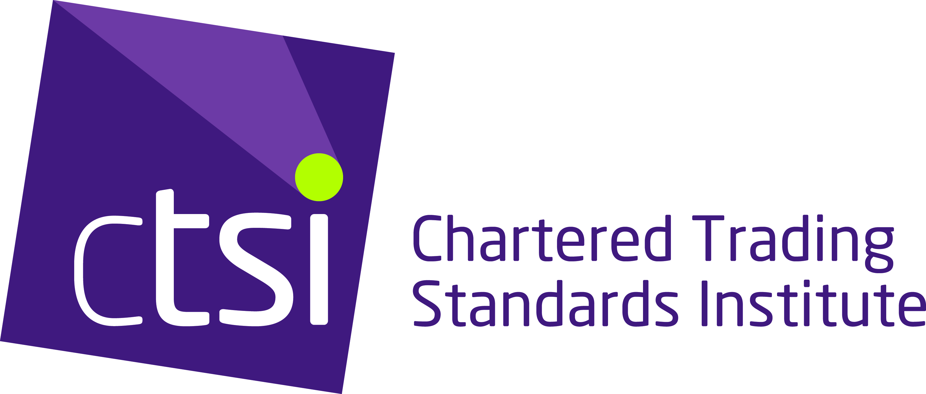

age 3

