Case Reference Form
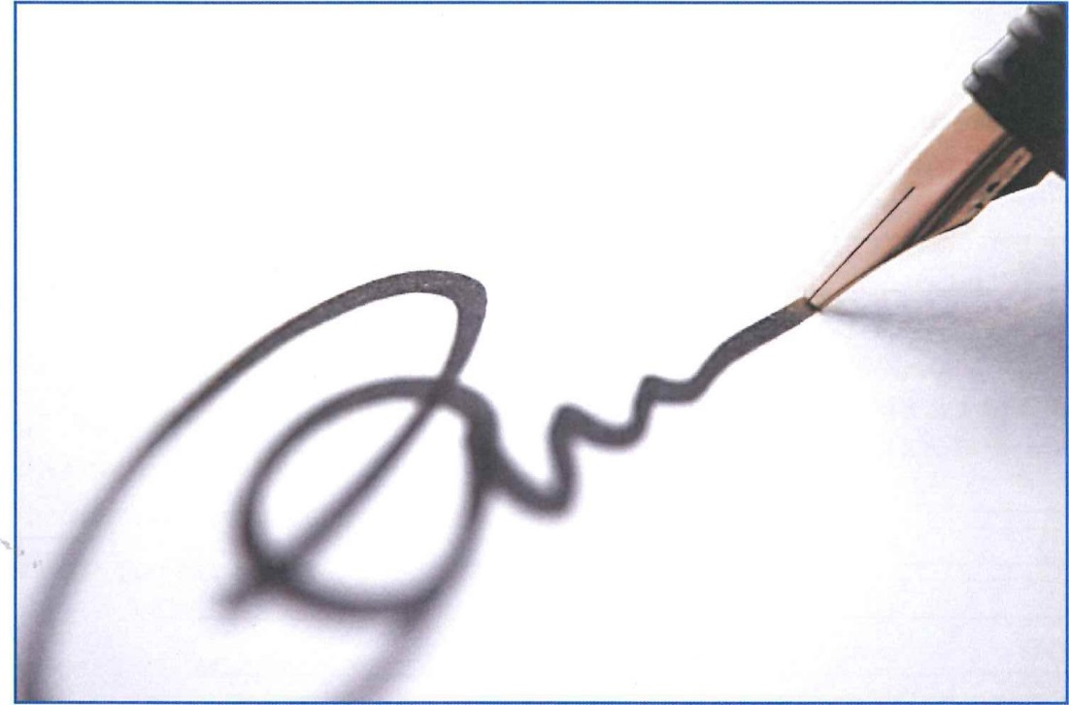

STEP 1 - HAVE YOU WRITTEN TO THE COMPANY?
Before completing this form, it is essential that you have referred your enquiry in writing to a Senior Manager of the Company concerned. They must be given time to respond and issue you with their Final response to the matter.
STEP 2 - DISSATISFIED WITH THE COMPANY'S RESPONSE?
Any copy correspondence and invoices etc. must be placed in rising date order, i.e. newest at the top. No staples please!
Please only submit A4 size paper (the same as our letters) with text on one side. Not double-sided.

Before completing and returning this form, it is important that you read the accompanying leaflet ‘NCS Resolving Disputes Within the Motor Industry and complete preliminary questions 1 to 3 below
1. | Have you addressed your complaint in writing to a senior member of staff at the company concerned, allowed them adequate time to (fully?) investigate the dispute, but are unhappy with their final response and/or offer to settle the matter? YES / NO  If you have answered YES please include or attach a copy of their final response letter  IMPORTANT: If you answered NO please write to a senior member of staff at the company concerned and allow them time (to investigate) and respond to your complaint.
2. | If you answered YES to question 1:  - What is his/her name? _____________________________________________________  - What position do they hold in the company? ____________________________________
3. | Is your dispute currently being investigated, or has it been investigated, by any other body e.g. the Civil Courts, Trading Standards, Financial Ombudsman of an alternatives provider of ADR etc? YES / NO  If YES please give details:  _________________________________________________________________________________  _________________________________________________________________________________  _________________________________________________________________________________  IMPORTANT. If you answered YES, it is most unlikely we can pursue your complaint (please refer to  'How National Conciliation Service Helps You -The Customer').  If you answered NO please complete the rest of the form
4. | Your title, name and full address (IN BLOCK CAPITALS PLEASE)  _________________________________________________________________________________  _________________________________________________________________________________  _____________________________________________ Postcode: ___________________________  Telephone: ___________________________________ Mobile: ______________________________  Email: ____________________________________________________________________________
5. | Name and full address of the business against which the complaint has been made (IN BLOCK CAPITALS PLEASE)  _________________________________________________________________________________  _________________________________________________________________________________  _____________________________________________ Postcode: ___________________________
6. | Which one of the following does your enquiry concern?  - Sales or administration issue with a recently purchased vehicle  - Technical incident(s) with a recently purchased vehicle  - General repair or maintenance of a vehicle  - Other subject |  | Please complete the following sections shown on the line you have ticked  (Brackets indicate not mandatory)  PLEASE TICK ONE BOX  7, 8, 9, 10, 11, (13)  7, 8, 9, 10, 11, (12), (13)  7, 8, 9, 10, (11), 12, (13)  7, 8, 9, (10), 11, 12, (13)
7. | Brief summary of complaint to explain why you consider the company is liable:  _________________________________________________________________________________  _________________________________________________________________________________  _________________________________________________________________________________  _________________________________________________________________________________  _________________________________________________________________________________  _________________________________________________________________________________
8. | What sum is in dispute? £__________________
9. | What would you consider a fair settlement? £__________________  Please provide evidence eg invoices etc and substantiate/quantify your claim  Why? _______________________________________________________________________________
10. | VEHICLE DETAILS
 | - Make? e.g. Ford
 | - Model? e.g. Fiesta Zetec – S
 | - Body type and number of doors? e.g. Saloon 4 door
 | - Factory Extras? e.g. sunroof, metallic, sat nav, alloys
 | - Engine Size? e.g. 1.4
 | - Fuel Type? e.g. Petrol, Petrol/LPG, Diesel, Hybrid, Electric
 | - Transmission? e.g. Manual, Auto, Semi, Auto
 | - Registration Number?
 | - Date of original registration?
 | - Date of purchase by you?
 | - From where did you buy the vehicle?
 | - What was the recorded mileage when you bought the vehicle?
 | - What is the mileage now?
 | - Do you still own the vehicle?
11. | VEHICLE PURCHASE DETAILS |  |  | PLEASE TICK BOXES
 | - Please enclose copy of vehicle invoice |  |  | ENCLOSED
 | - Was a warranty given at the time of purchase? |  |  | YES |  |  |  |  | NO
 | - If it was a manufacturer’s warranty, what was the duration?
 | - If it was a used vehicle warranty, what was the duration?
 | - Please enclose copy of relevant section of the warranty |  |  | ENCLOSED
12. | DETAILS OF THE ORIGINAL REPAIR OR SERVICE FROM WHICH YOUR ENQUIRY RISES
 | - Date of original repair/service from which your enquiry arises?
 | - Recorded mileage at that time?
 | - Name of company that undertook the work?
 | - Details of work you requested?
 | - Please enclose copy of invoice |  |  | ENCLOSED
 | - Was an estimate or quotation provided? |  |  | YES |  |  | NO
 | - If YES, how much was it? |  |  | £___________________
 | - Please enclose a copy of quotation if provided |  |  | ENCLOSED
 | - If relevant, what old parts are available for inspection?
13. | ADDITIONAL INFORMATION, IF ANY. PLEASE CONTINUE ON A SEPARATE SHEET IF NECCESSARY  _________________________________________________________________________________  _________________________________________________________________________________  _________________________________________________________________________________  _________________________________________________________________________________  _________________________________________________________________________________
PLEASE TICK BOXES – FAILURE TO DO SO WOULD CAUSE DELAYS IN THE PROCESS
 | I CERTIFY that to the best of my knowledge and belief the information I have given on this form is true
 | I agree to the National Conciliation Service Code of Practice
 | I have read and understand the National Conciliation Service Privacy Policy
Signed: |  | Date:
Please Print Name:
WHEN COMPLETING THE ABOVE FORM, PLEASE REFER TO THE GUIDANCE NOTES BELOW
Consumer Case Reference Form guidance notes

PLEASE REFER TO THESE NOTES FOR GUIDANCE ON HOW TO COMPLETE THE CASE REFERENCE FORM.

Preliminary information
Step 1 Please confirm that you have contacted the accredited business and received either a final response or given them 8 weeks to investigate your concerns before contacting The National Conciliation Service (NCS) The NCS will not be able to progress your case until you have done so

Step 2 If you are Dissatisfied with the Company’s Response – Please complete this form after reading ‘How the National Conciliation Service Helps you’ – enclosing copies of any correspondence invoices etc., in support of your complaint

Please Note; Do not send original documents, only copies as the NCS are unable to return them Please list documents in rising date order, i.e. newest at the top, and please do not use staples and use A4 size paper if possible, with text on one side only.

Please be aware that all documentation sent by either party in support or defence of this dispute will be shared equally between all the concerned parties and the case handler/s* involved in the case (*conciliator/mediator, ADR officials, arbitrator/s or adjudicator)

Q1 Have you addressed your complaint in writing to the business? It is important that you have given the business every opportunity to investigate and respond to your dispute before you contact the NCS

Q2 Name of the person who dealt with your complaint In this section, please give full details of the member of staff/person that finally dealt with your complaint

Q3 Is or has your complaint been investigated by any other body? Please tell us if your complaint is currently being or has previously been investigated by any other body. e.g. the Civil Courts, Trading Standards, Financial Ombudsman Service or an alternatives provider of ADR, As If it is or has, the NCS may not be able to help you with your dispute

Q4 Your name and full address; Please supply your daytime contact details including email address if possible

Q5 Name and full address of the business against which this complaint is about? Please provide full contact details including name and telephone number

Q6 Which one of the following does your enquiry concern? Please tick the box that represents the nature of your complaint, e.g. vehicle purchase, service or repair etc

Q7 Brief summary of why you think the company is liable? Please give a brief summary of your complaint and why you consider the business to be liable

Q8 What sum is in dispute? Please state the monetary sum that is in dispute if any

Q9 What would you consider fair settlement? Please state what you would consider fair financial settlement of your dispute, or what you require the trader to do to settle the matter – If financial settlement is required please provide evidence to substantiate your claim e.g. invoices, receipts etc

Why? Please give a brief explanation as to why you think the business is to blame

Q10 Vehicle Details. Please complete this section

Q11 Vehicle Purchase details. Please complete this section and enclose a copy of any invoice, warranty etc., if applicable – Please send copies only NOT originals

Q12 Details of original repair/service from which your complaint arises?
If applicable, please complete this section giving as much detail as possible and enclose copies of any invoices, estimates etc., in support of or relevant to your complaint – Please send copies only, not originals as they cannot be returned

Q13 Additional information, if any. Please supply any additional information you have that may support your complaint

Please only attach/enclose the most recent and relevant correspondence from the business and/or the most recent correspondence you have sent to them. Please also attach any information which you would like the NCS to consider when deciding your complaint e.g. invoices, service history documentation, warranty booklet, sales documents, technical reports etc., copies only please

Submitting the completed form

File your Complaint
You can submit your form by one of the following methods:
File your complaint online by following the steps via this link; www.nationalconciliationservice.co.uk
By Email: crf@nationalconciliationservice.co.uk
Or by Post: The National Conciliation Service, PO Box 6562, Rugby CV21 9QP

NATIONAL CONCILIATION SERVICE
PO Box 6562, Rugby, Warwickshire CV21 9QP
National Conciliation Service is approved by Government under the Alternative Dispute Resolution for Consumer Disputes (Competent Authorities and Information) Regulations 2015.
Limited company number: 9653315. Registered Office; 201 Great Portland Street, London, W1W 5AB. The information commission certificate of registration number: ZA132306
The National Conciliation Service is authorised by Government under the Alternative Dispute Resolution for Consumer Disputes (Competent Authorities and Information) Regulations 2015

